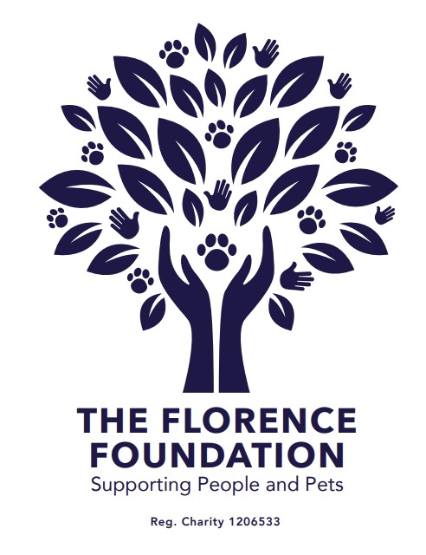
WHO AND WHAT WE FUND
Applicant guidance
APPROVED
August 2026 | v 1.0

At a glance: We fund Charity Commission-registered charities working in England. We give priority to work in Lancashire, Greater Manchester, Merseyside and Cheshire. The maximum grant we award is £10,000, the average size of grant awarded to date is £6,500.

1. About the Florence Foundation
The Florence Foundation (TFF) supports people and pets. We award grants that advance animal welfare and pet rescue, support pet food banks, or prevent and relieve poverty, including through food banks and pantries.
2. Check that your charity is eligible
Your organisation must meet every requirement below:
- be a charity registered with the Charity Commission for England and Wales;
- be based in England and carry out the proposed work in England;
- have at least two years of accounts filed with the Charity Commission, with filings up to date;
- have a bank account in the exact name of the registered charity;
- apply through an individual who is known to and authorised by the charity; and
- request no more than £10,000 for a funding period of up to 12 months, unless we agree a longer period as an exception.
- applications that are supported by clear priorities, scope of grants, detailed spending plans and anticipated impacts are more likely to be successful.

There are no exceptions to the registration or two-filed-accounts requirements. Meeting the eligibility requirements does not guarantee funding.
3. Our priority area
We accept applications from eligible charities anywhere in England. We give priority to work benefiting Lancashire, Greater Manchester, Merseyside and Cheshire. Cumbria is not included in TFF’s priority area.
Indicative postcode areas include BB, BL, CH, CW, FY, L, M, OL, PR, SK, WA and WN, plus Lancashire addresses in the LA postcode area. Postcodes cross county and regional boundaries, so this list is a guide rather than the final eligibility test. We will consider where the people, pets or services benefiting from the grant are located.
4. Animal welfare and pet rescue grants
The charity’s main activity must be rescuing and rehoming domestic pets, or operating a pet food bank. Domestic pets include cats, dogs, rabbits, guinea pigs, hamsters, gerbils, degus, mice, chinchillas, rats, parrots and pet birds, commonly kept reptiles, ferrets, chickens and equines.
For rescue and rehoming applications, the funded work must directly improve the welfare of pets in rescue or help reduce the number of pets in rescue. Eligible organisations may include national charities and their branches, independent rescue centres and foster-based rescues. Typical grants can cover;
- Veterinary treatment and bills.
- Boarding costs.
- Food.
- Capital projects, vehicles, equipment and building work that directly support eligible rescue activity.

Where applicable, rescues must vaccinate, microchip, neuter and treat animals for fleas and worms before rehoming. If neutering before adoption is not possible, the rescue must use an appropriate adoption agreement committing the new owner to later neutering. Dog or cat rescue and rehoming charities with annual income over £1 million must be members of the Association of Dogs and Cats Homes.
5. Poverty-relief grants
The charity’s main activity must prevent or relieve poverty by helping people address the causes or consequences of poverty or financial crisis. Eligible work may include homelessness support, emergency accommodation, education access for young people, family support, food banks and pantries, pet food banks, essential services, furniture or equipment. This is not an exhaustive list. Typical grants support;
- Running costs directly connected with eligible services.
- Capital projects, equipment, vehicles and building work.
- Specific projects aligned with TFF’s charitable purposes.
- Delivery of services and costs associated with staff or volunteers directly delivering eligible services.
We consider building renovation or new-building work only where the building’s main use is accommodation or facilities for people experiencing homelessness, or community-based work addressing poverty or its causes.
6. What we do not fund
- Any cost committed, invoiced, paid or incurred before the grant is awarded. Grants are for future costs only.
- General salaries or charity overheads unless directly attributable to an eligible project or direct service.
- Uniforms or personal expenses.
- Vehicle leasing, road tax, insurance or fuel.
- The purchase of land or existing buildings.
- Charity-shop costs.
- Fundraising costs, including general marketing materials.
- Routine onward grant-making by another grant-making organisation, unless TFF agrees otherwise before application.
7. What to include with your application
Explain clearly what you want to do, why it is needed, who or what will benefit, when the work will happen, how much it will cost and what difference the grant will make. Information must be complete, accurate and truthful.
- Capital items or equipment: at least one current supplier quote; two quotes for a vehicle.
- Building work or refurbishment: at least two supplier quotes covering most of the cost; evidence that the charity owns the property or holds an adequate lease; and planning consent where required.
- Where relevant: architectural plans, photographs and the business or strategic plan supporting the project.
- If the latest filed accounts cover a financial year ending more than 12 months ago: current draft or management figures.

We may request clarification, additional documents, independent references or an in-person or video visit. Please do not include identifiable or sensitive beneficiary information unless it is necessary and you have a lawful basis to share it. Case studies may be anonymised.
8. How decisions are made
- Submit the online application by the published deadline.
- We check eligibility and may carry out proportionate due diligence.
- All grant awards are decided by the trustees at grant meetings, normally held in June and November.
- We notify every applicant of the outcome within 10 days of the trustee meeting.
- Because of application volumes, we do not provide individual reasons to applicants that are ineligible or unsuccessful. An unsuccessful applicant may apply again in the next application window.
- A successful applicant must accept our Grant Terms and Conditions, provide bank details and complete final checks.
- Once we receive complete and satisfactory documents, we normally pay within seven days by bank transfer to an account in the registered charity’s name.
9. After an award
Every recipient must complete our TFF online post-grant evaluation. The default reporting date is six months after payment. A recipient may request a longer reporting period where this better matches delivery. We will contact the recipient automatically with the form.
Recipients must tell us promptly if the funded work, budget, timetable, governance or ability to deliver changes materially. Any material change requires TFF’s written approval before the grant is used differently.
10. Privacy, accessibility and complaints
We handle application and grant information in accordance with the Florence Foundation Privacy & Cookie Policy, available at www.florencefoundation.org.
For an eligibility question, a reasonable adjustment or an alternative format, contact the Chair at info@florencefoundation.org. Asking for support will not affect the decision.
A complaint may concern the administration or fairness of the process, but not disagreement with the trustees’ funding judgment. Address procedural complaints to the Chair at info@florencefoundation.org. Trustee funding decisions are final.

