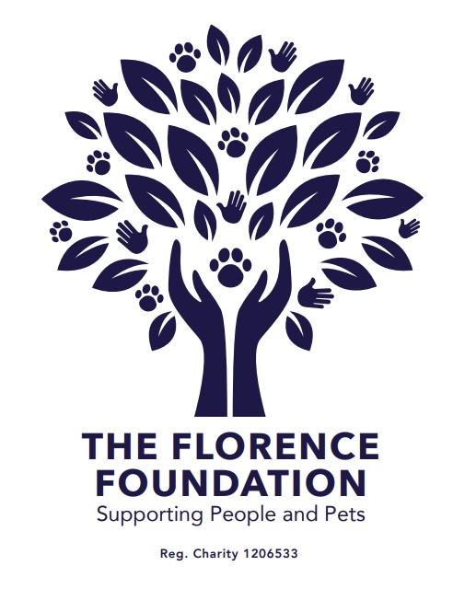

PRIVACY & COOKIE POLICY

APRIL 2026
V1.0

Privacy & Cookie Policy
The Florence Foundation
Last updated: April 2026

Who We Are
The Florence Foundation is a UK-registered charity supporting:
- Animals in care and pet rehoming
- Individuals and families facing hardship
Data Controller:
The Florence Foundation
C/O Sedulo London Limited, 605,Albert House, 256-260 Old Street, London, EC1V 9DD
Email: info@florencefoundation.org
Charity Number: 1206533

Your Privacy Matters
We are committed to protecting your personal data and being transparent about how we use it.
This policy explains how we collect, use, and safeguard your information when you:
- Visit our website (www.florencefoundation.org)
- Apply for a grant
- Contact us
We comply with the UK GDPR and the Data Protection Act 2018.

What Data We Collect

Information You Provide
- Name, email address, phone number
- Organisation and charity details
- Charity registration number and financial information
- Information included in grant applications or enquiries

Automatically Collected Data
When you use our website, we may collect:
- IP address
- Device and browser type
- Pages visited and time spent
- Website interactions (via analytics tools)

Sensitive Information
We do not actively collect sensitive personal data. If it is included in grant applications, it is handled securely and only used where necessary.

How We Use Your Data

Grant applications are reviewed by trustees and retained for governance, audit, fraud prevention, and regulatory compliance purposes.
We use your information to:
- Assess and manage grant applications
- Communicate with applicants and partners
- Improve our website and user experience
- Meet legal and regulatory obligations
- Maintain records for governance and audit

Legal Basis for Processing
We process your data under:
- Legitimate Interests – running the charity and awarding grants
- Legal Obligation – compliance with charity and regulatory requirements
- Consent – where you opt in (e.g. contact forms or cookies)

How We Share Your Data
We do not sell your data.
We may share your information with:
- Trustees (for grant decision-making)
- Service providers (e.g. Wix, Google Analytics)
- Regulators or authorities where required
All third parties are required to keep your data secure.

Data Storage & Security
We use secure systems to protect your data, including:
- Trusted platforms (e.g. Wix hosting)
- Restricted access controls
- Secure cloud storage
Some data may be processed outside the UK with appropriate safeguards.

How Long We Keep Your Data
- Grant applications: up to 6 years
- Enquiries: as needed for operational purposes
- Website analytics: based on tool settings

Your Rights
You have the right to:
- Access your data
- Correct inaccurate data
- Request deletion
- Object to or restrict processing
- Withdraw consent
You can also complain to the Information Commissioner’s Office (ICO):
https://www.ico.org.uk

Contact Us
For any privacy queries:
Email: info@florencefoundation.org

Cookie Policy

What Are Cookies?
Cookies are small text files stored on your device when you visit a website. They help improve your experience and allow us to understand how the site is used.

How We Use Cookies
We use the following types of cookies:

Essential Cookies
Required for the website to function properly (e.g. page navigation, security).

Analytics Cookies
Used to understand how visitors use our site (e.g. Google Analytics). This helps us improve performance and content.

Functionality Cookies
Remember your preferences (e.g. returning visitor recognition, form data).

Third-Party Cookies
We may use trusted third-party services, including:
- Wix (website hosting and functionality)
- Google Analytics (website performance tracking)
These providers may collect anonymised data about your usage.

Managing Cookies
You can control or delete cookies through your browser settings.
When you first visit our website, you will be asked to accept or manage cookie preferences.

