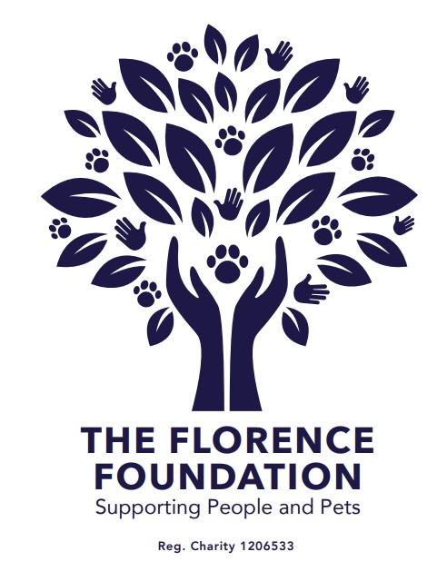

TRUSTEE RECRUITMENT POLICY

November 2025
V2.0

Policy name: Florence Foundation Trustee Recruitment Policy
Adopted on: 29th November 2025
Review date: November 2026

Purpose:
The Florence Foundation recognises that the strength and effectiveness of the charity depend upon having a diverse and skilled Board of Trustees. To ensure good governance, transparency and continuity, the charity has adopted the following approach to recruiting and appointing new trustees.
Process:
When a vacancy arises, the Board will undertake a review of the current skills and experience represented within the trustee group. This “skills audit” will help identify gaps in knowledge or expertise that would strengthen the charity’s ability to meet its objectives. In particular, the Foundation values skills in areas such as charity governance, financial management, fundraising, communications, safeguarding, animal welfare, and community engagement with vulnerable groups.
Trustee opportunities will be advertised openly where appropriate, and the Foundation will seek to attract candidates from a wide range of backgrounds to ensure diversity of thought and representation. Informal expressions of interest may also be considered, provided the candidate meets the required skills and commitment standards. All prospective trustees will be provided with clear information about the role and responsibilities of charity trustees, as set out by the Charity Commission.
Applicants will normally be invited for an informal discussion with existing trustees to assess their suitability, alignment with the Foundation’s values, and capacity to contribute effectively. References may be sought where relevant. Formal appointment will be confirmed by resolution of the Board, and all new trustees will complete the statutory declarations required under charity law.
To support effective induction, new trustees will be provided with an introduction to the charity’s work, governance policies, and current priorities. Ongoing training and development will be encouraged to maintain high standards of governance and to ensure the Board continues to act in the best interests of the charity and its beneficiaries.

Signed:
Chair of Trustees: PETER PRITCHARD
Date: __ / __ / ___

Appendix: Trustee Skills Matrix
The Florence Foundation seeks to ensure that the Board of Trustees collectively possesses the skills, knowledge, and experience necessary to govern effectively and support the charity’s mission. The following table illustrates the key areas of expertise the Board aims to maintain:
Skill / Experience Area | Purpose / Relevance
Charity Governance & Compliance | Ensures trustees understand legal duties, regulatory requirements, and good governance practice.
Financial Management & Audit | Supports robust financial oversight, budgeting, and accountability.
Fundraising & Income Generation | Guides income diversification and sustainability of activities.
Animal Welfare & Care | Provides insight into the charity’s mission to support animals in care.
Poverty & Community Support | Strengthens understanding of issues faced by people in crisis and the organisations supporting them.
Safeguarding & Welfare | Maintains best practice in protecting vulnerable beneficiaries.
Communications & Public Engagement | Supports advocacy, awareness-raising, and building strategic partnerships.
Human Resources & Volunteer Management | Contributes to effective oversight of staff and volunteer development.
Legal & Risk Management | Enhances decision-making around contracts, policies, and organisational risk.
Diversity & Inclusion | Ensures the Board reflects a broad range of perspectives and lived experiences.

